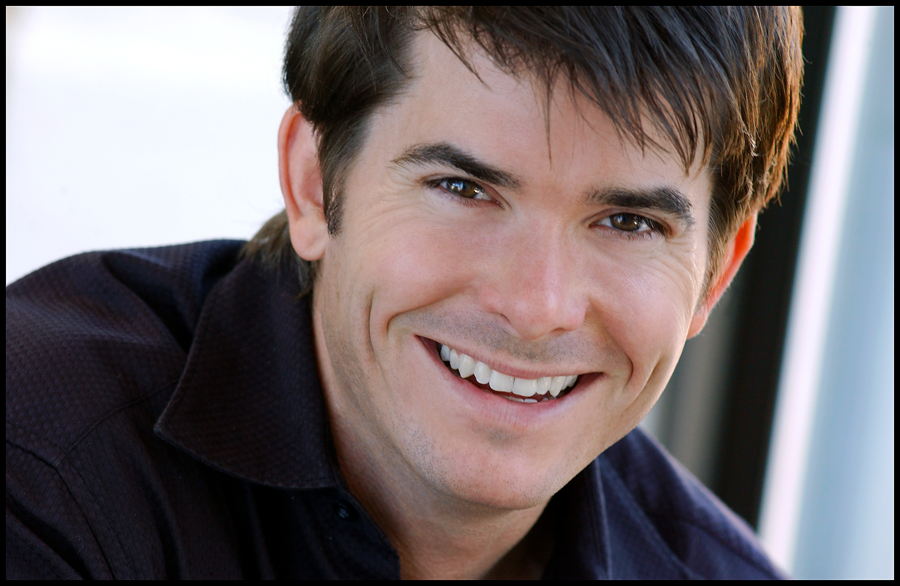
Kevin Kraft
Wgt: 150
Hgt: 5’’10”

For Agents click “Representation”at www.KevinKraft.com

SAG AFTRA AEA CAEA

www.KevinKraft.com

FILM & TV
THE NANNY DIARIES Supporting Weinstein / Film Colony Dir. Robert Pulcini
DUNSTON CHECKS IN Supporting 20th Cent Fox, Dir. Ken Kwapis
ED Supporting Universal Studios
KISS OF A KILLER Supporting ABC MOW
REBELS AND REDCOATS Lead - Dr. Thatcher BBC
SHOWTIME NIGHTTIME Lead - On Air Host Showtime Nighttime Programming Host
ALL MY CHILDREN Recurring - Tommy Brusard ABC
WRITERS BLOCK Sketch Comedy Cast Pilot
LAST CHANCE DETECTIVES Supporting LCD Video Series
LATE NIGHT WITH CONAN O’BRIEN Recurring - Comic Bits NBC
THE LATE SHOW (LETTERMAN) Recurring - Comic Bits CBS

BROADWAY
A FUNNY THING...FORUM Lead - Hero SB (performed) Dodger Theatricals, Dir. Jerry Zaks
(w/ Nathan Lane & Whoopi Goldberg)
THE HUNCHBACK OF NOTRE DAME Supporting Production Workshop, Dir. James Lapine

NEW YORK THEATRE
JOHNNY GUITAR Turkey SB (performed) Original OFF-BW Cast - Century Center Theatre
AMERICAN DREAMS Bob Ziak Original OFF-BW Cast, The Acting Co. Lucille Lortel Th.
THE FARTISTE (Best Musical NYFF) Joseph Pujol Original Cast – Harry de Jur Playhouse
CARRIN BEGINNING Marc Chelsea Theatre/Riverside Stage

THEATRE
AS YOU LIKE IT Orlando and Amiens The Acting Company
SHE LOVES ME Georg The Arena Stage, Dir. Kyle Donnely
FLOYD COLLINS Homer Actors Theatre of Louisville
HOUDINI Harry Houdini Segal Center, Montreal (World Premier)
BARNUM Ringmaster & 8 other roles The Asolo
THE FULL MONTY Jerry West Virginia Public Theatre
MASTER HAROLD &THE BOYS Hally St. Michael’s Playhouse

BAREFOOT IN THE PARK Paul St. Michael’s Playhouse
HAY FEVER Simon Theatre Virginia
A CHRISTMAS CAROL Peter, Adult Tiny Tim Ford’s Theatre
DR. JEKYL & MR. HYDE Harris Paper Mill Playhouse, Dir. Phil McKinley
GREASE Eugene Kansas City Starlight, Dir. Phil McKinley
THE MARRANO Raphael Massachusetts Rep, Dir. Mark Bramble

TRAINING
Michael Howard Studios (Michael Howard) Caryn West (Film & TV Audition Technique)
Beverly Hills Playhouse (Gloria Gifford) USC BFA Acting (Tad Danielewski & Stephen Book)
Don Phillip Smth (Acting for TV)

SKILLS
Songwriter (www.KevinKraft.com), Sing Play Guitar, Lute, Harmonica. Roller Blading, Multiple Marathon Runner. Strong Circus skills (juggling, etc), some Magic skills (coin/card manipulation, etc). Speak some Japanese. Face Balancer.
Dialects: South African, Irish, Cockney, Standard British, French.
Reel & more info available at www.KevinKraft.com

